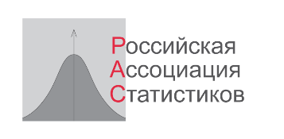

SAINT-PETERSBURG STATE ECONOMIC UNIVERSITY
DEPARTMENT OF THE FEDERAL STATE STATISTICS SERVICE IN SAINT-PETERSBURG AND THE LENINGRAD REGION (PETROSTAT)
SOCIOLOGICAL INSTITUTE OF THE RAS
RUSSIAN ASSOCIATION OF STATISTICIANS

Information letter No. 1

International scientific and practical conference
« Statistical Assessments of Sustainable Development»
January 27-28, 2022
Russia, St.Peterburg

Dear Colleagues!

We invite you to take part in the next international conference on statistical measurement and applied statistics.
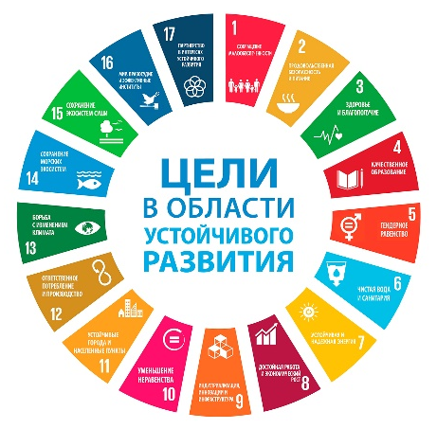
In 2015, the leaders of the Member States of the United Nations adopted the 2030 Agenda for Sustainable Development, which includes 17 global goals and 169 economic, social and environmental challenges that humanity must address in order to achieve sustainable development. The statistical community plays a huge role in this process. The purpose of the conference is to study, exchange and disseminate experience and knowledge in the field of theoretical foundations and practice of measuring sustainable development goals (SDGs).

Proposed areas of work for the conference:

Global and national SDG indicators:
What are the SDGs and how are they interrelated? Why is there no alternative to sustainable development today? What is the role of information and statistics in achieving the SDGs? What are the tools to measure the SDGs? How versatile are they? How are the global SDGs and national priorities aligned?

Green economy and green growth indicators:
The world continues to actively develop criteria and indicators of a green economy. What are their pros and cons? How to make environmental adjustments to traditional macroeconomic indicators and measure the environmental performance of the economy? Responsible production and consumption, green jobs, circular economy, green finance and innovation are the realities of the day. Are statistics ready to offer tools for monitoring these phenomena?

Monitoring of sustainable development of regions and cities:
What are the tools for measuring SDGs at the regional level? How are SDG indicators integrated into regional development programs? Discussion of the first practices for preparing voluntary local reviews on the SDGs.
ESG Business Transformation:
What is the current state and future development perspectives of business in Russia? How are global SDG transforming business-actions and affect the market? How effective is non-financial statement as a tool for assessment of sustainable development of organizations?

Qualitative data for the SDGs:
To achieve progress, it is necessary to regularly analyze a huge amount of information that meets the criteria of comparability, completeness, reliability, transparency, disaggregation and relevance. How to close data gaps for the SDGs? What are the modern standards and formats for collecting, processing, transferring and storing data, and what are the demanded formats for presenting data? The role of non-traditional sources of information for monitoring the SDGs. How to communicate the achievement of the SDGs in an accessible and understandable language?

SDGs in the context of the COVID pandemic:
COVID-19 has seriously impacted the trajectories of reaching the 2030 Agenda. What are the observed and expected impacts of the pandemic on the SDGs, is there a need for data innovation in the COVID-19 era?

Within the framework of the conference, it is planned to hold round tables:
A. Resilience of family and marriage
B. The Arctic as a subject of sustainable development
C. Modern statistical education

Working language: Russian
Format: offline and online
Venue: St. Petersburg, Griboyedov Canal Embankment 30/32, St. Petersburg State University of Economics
To register for the conference as a listener or speaker, follow the link
https://docs.google.com/forms/d/e/1FAIpQLSdiU3VJ6DKQUt2DUsxWnqcUq5g2baW7ecjlG--rT5W_hiNuzw/viewform

To participate with a report after registration, you should send the article by December 15, 2021 to konf_statistica@mail.ru. The circle of participants and the conference program will be formed on the basis of applications.

The collection of conference materials will be published in electronic form.

The best reports will be recommended for publication in the journals of the Higher Attestation Commission, including the journal "Finance and Business". Articles recommended for publication must be sent by February 15, 2022. Requirements for the design will be sent out additionally.
Participation in the conference is free, no registration fee is provided.

Chairman of the conference program committee
Corresponding Member RAS, Scientific Director of RAS,
head Department of Statistics and Econometrics, SPbSEU I.I. Eliseeva

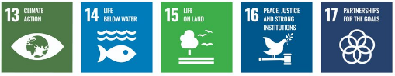
Requirements for conference materials

The text of the article should be sent in electronic form in an MS Word file and formatted in accordance with the example.
Text: TimesNewRoman font, 10 pt, 1.0 spacing. The text should be typed without hyphenation and aligned to the width of the page. The volume of the article should not exceed two A4 pages.
Title: Full name in the upper left corner (bold), below: academic degree, academic title, position, organization name (italics), below the heading with the title of the article (center alignment; bold letters).

Example of registration

Eliseeva I.I.
Corresponding member RAS, doct. econom. sciences, prof.,
head Department of Statistics and Econometrics, St. Petersburg State University of Economics

Government statistics as a public good: an introduction to the problem

Article text

The list of references is given at the end of the article in alphabetical order by the names of the authors in accordance with the accepted standards of bibliographic description. Links to the cited sources are given in parentheses indicating the authors and the year of publication of the corresponding work, for example, (Petrov, 2016, p. 23) or (Statistical collection ..., 2018, p. 56).

References
O nekotorykh voprosakh, svyazannykh s vvedeniyem v deystviye protsedur, primenyayemykh v delakh o nesostoyatel'nosti (bankrotstve) grazhdan [On some issues related to the introduction of procedures used in cases of insolvency (bankruptcy) of citizens] , Resolution of the Plenum of the Supreme Court of the Russian Federation of 13.10.2015 N 45 (Electronic version: http://ppt.ru/newstext.phtml?id=8189514)

Eliseeva I.I., Raskina Yu.V. Izmereniye bednosti v Rossii: vozmozhnosti i ogranicheniya [Measuring Poverty in Russia: Opportunities and Limitations]. Voprosy statistiki [Statistical Issues], 2017, N 8, pp. 70-89.

