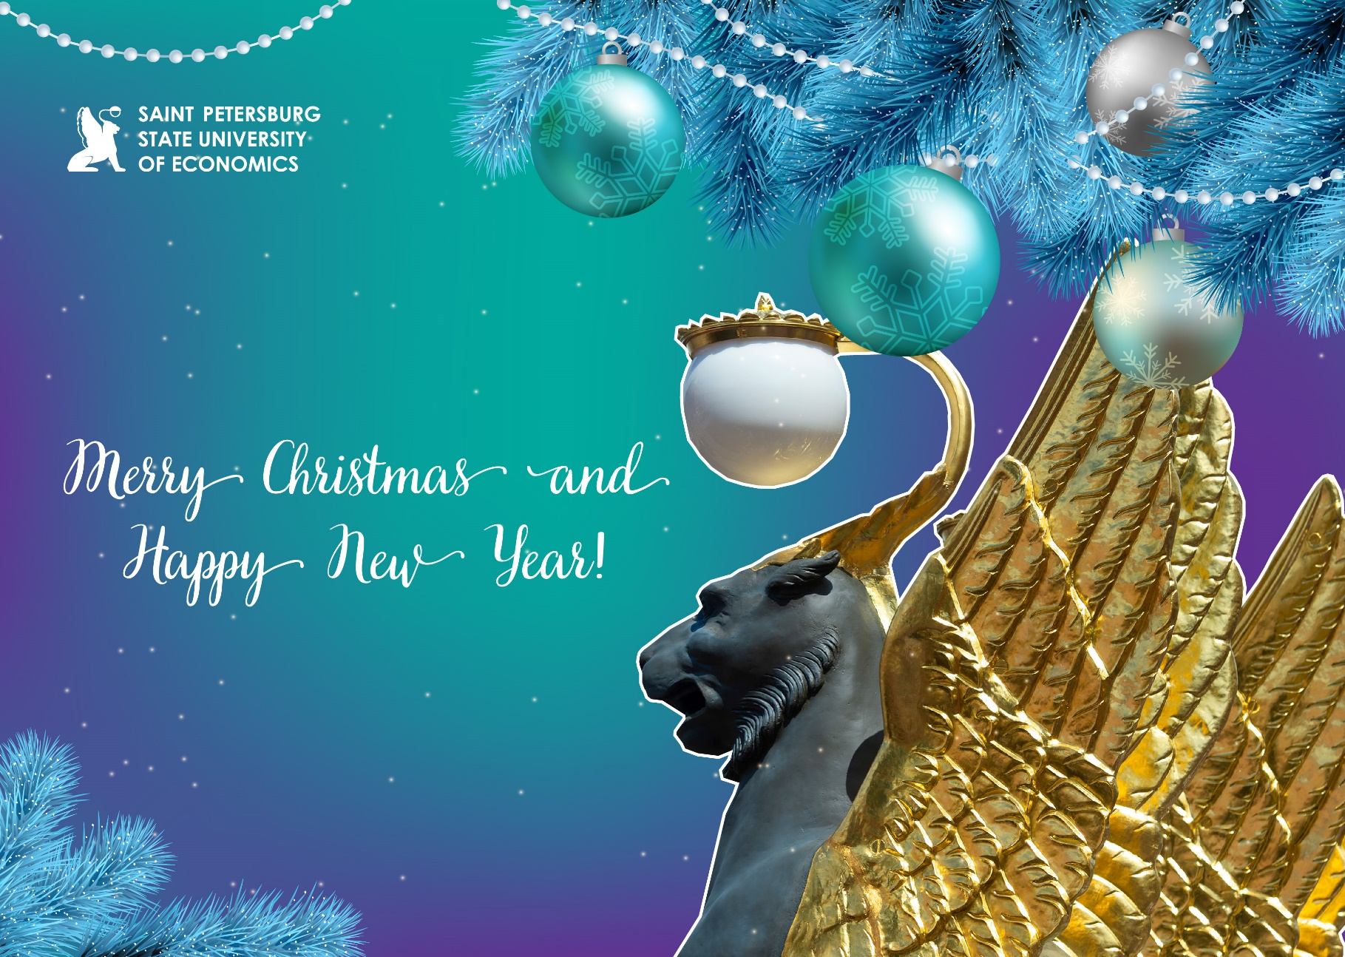

***Dear colleaguesc!***

***On behalf of Saint Petersburg State University of Economics I wish you Merry Christmas and a Happy New Year!***

***I wish you and your nearest and dearest good health, prosperity and realization of all plans! Let the New Year 2024 bring many bright and happy moments, and may success and fortune accompany you in all good endeavors!***

***Rector 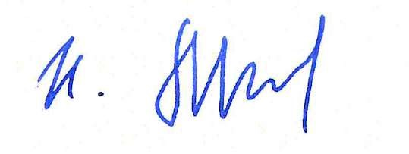 Igor Maksimtsev***